NBN ideas

We will have a colour scheme of a black background colour with a white font and green as the addition colour in order to stick to NBNs website colour scheme.

We will use the HTTPS protocol for the connection to the server to keep the attendee's data secure as well as hashing the passwords on the database to avoid account hacking.

We will have an events tab with A voting system will be in to allow attendees to vote on ideas in the Annual general meeting with a Yes or No response.

We will also implement a scheduler system to tell the user what time different workshops will take place so users can see which ones they can attend and manage their time. The schedule system would be structured as a timeline.

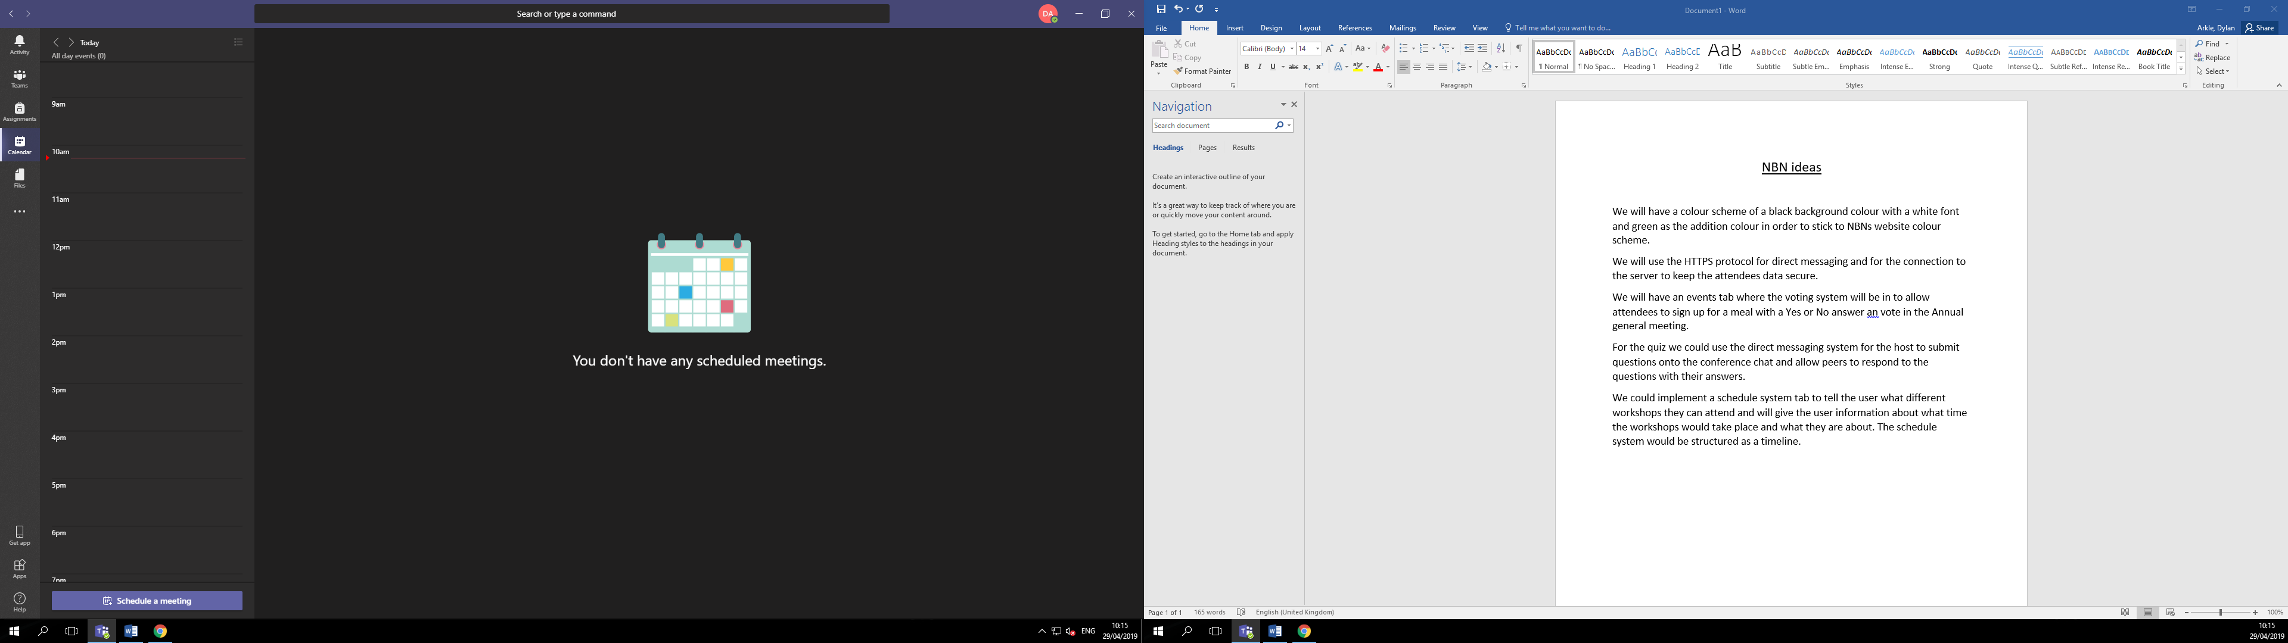Example of a timeline system in MS Teams

We could set up a reminder system using push notifications for the events users have signed up for and can warn the user 10 minutes before an event is about to start. The scheduler page will show the user all the events they have signed up in chronological order.